**DLCV Assignment-1**

**Devanshu Sharma 21UCC034**

Use YOLO (any version) for object detection in an image. The image should have at least three objects. The result should contain classes and confidence scores with the bounding boxes on the image.

from google.colab import drive

drive.mount("/content/gdrive")

Mounting the Google Drive using Google CoLab Library.

%cd /content/gdrive/MyDrive/Study Material/Semester 6/Deep Learning For Computer Vision DLCV/

Created a repository in my Google Drive as “Assignment-1” if it does not exist then make a new one here.

!pwd

import os

if not os.path.isdir("Assignment-1"):

os.makedirs("Assignment-1")

%cd Assignment-1

The os.path.isdir("Assignment-1") function checks if a directory named "Assignment-1" exists in the current working directory. If the directory exists, the condition will evaluate to True, indicating that the directory is present.

If the directory does not exist, the os.makedirs("Assignment-1") function is called. This function creates a new directory named "Assignment-1" in the current working directory. All intermediate directories required to create this directory will also be created if it does not already exist.

!git clone https://github.com/WongKinYiu/yolov7.git

%cd yolov7

!wget https://github.com/WongKinYiu/yolov7/releases/download/v0.1/yolov7.pt

Cloning the YOLO Model

Implementation of the YOLO V7 Model

!pwd

!python detect.py --weights yolov7.pt --conf 0.5 --img-size 640 --source 8.jpg

It initiates the detection process using the YOLOv7 object detection model with the following parameters :-

--weights yolov7.pt: It specifies the path to the YOLOv7 model weights file that will be used for the detection process.

--conf 0.5: This sets the confidence threshold for detection at 0.5. Objects detected with a confidence lower than this value will be filtered out.

--img-size 640: This sets the input image size for the detection process to 640x640 pixels.

--source 8.jpg: This specifies the source of the input for the detection process, in this case 8.jpg.

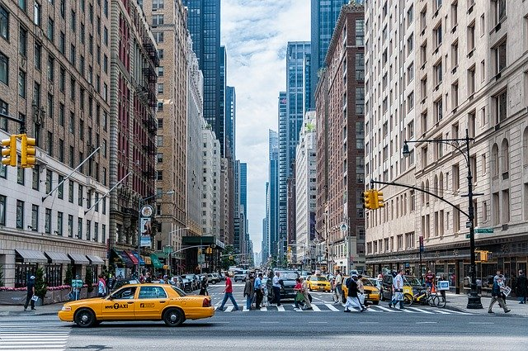

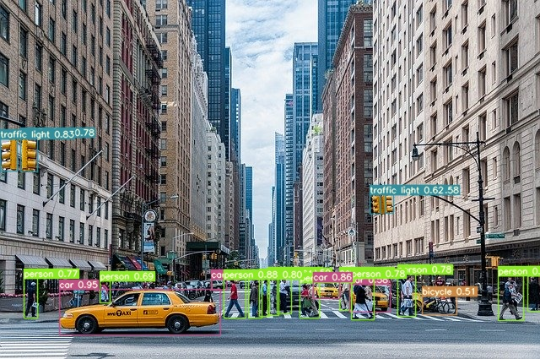

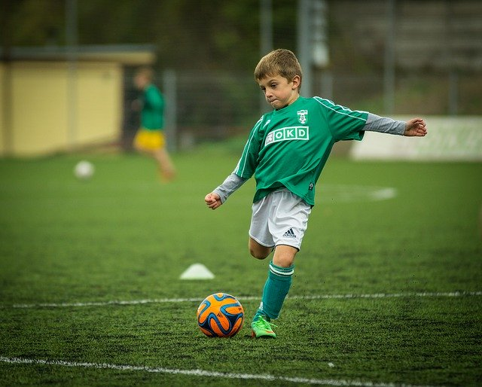

After executing the above code we get the detected image in our run detect folder as shown below contain classes and confidence scores with the bounding boxes on the image.

YOLO (You Only Look Once) is a real-time object detection algorithm that can detect multiple objects in an image or video. YOLO divides the input image into a grid and assigns bounding boxes and class probabilities to each grid cell. This allows for efficient and accurate detection of objects of various sizes and categories in real time.

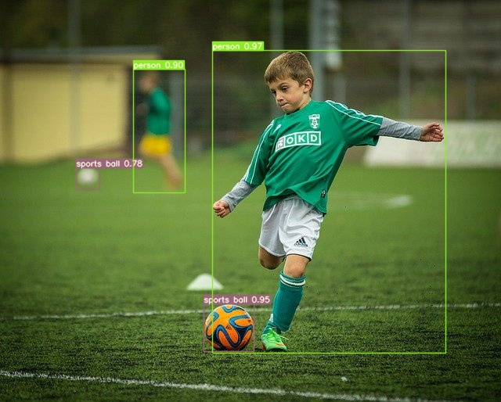

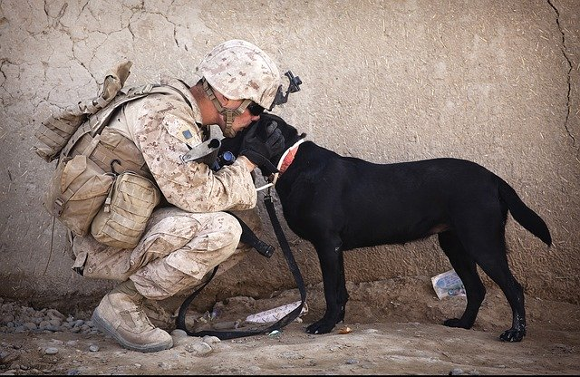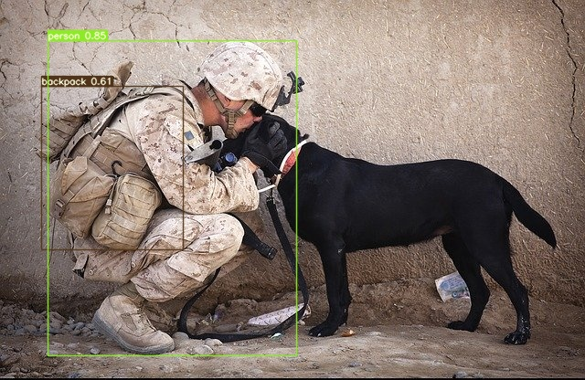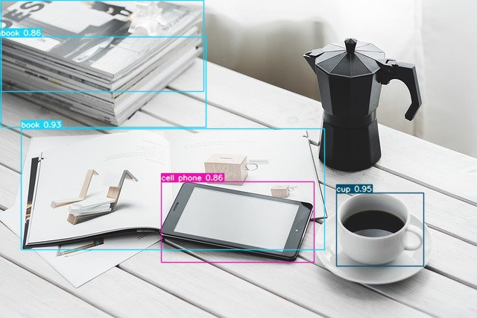

The full source code along with report is organized here [Assignment](https://drive.google.com/drive/folders/17-6r1l0SljFRoTXqjM6ppwSP2WZezGfo?usp=drive_link)